Lab – Servo Motor

1. Topology

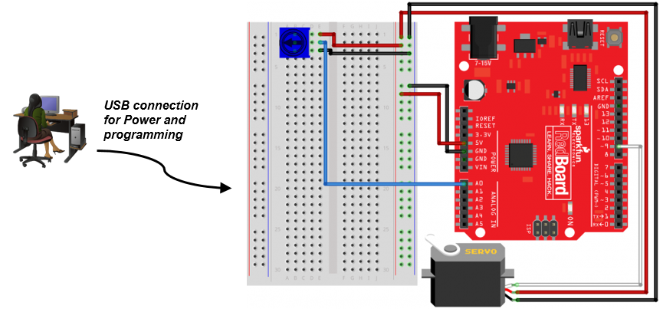

1. Objectives

* **Connect the circuits between the breadboard and RedBoard**
* **Load and run the sketch in the Arduino IDE**
* **Control the rotation of a small servo motor**

1. Background / Scenario

This lab will make use of a potentiometer to change resistance based on the position of the knob on the potentiometer. The varying resistance will then be used to control the voltage sent to the Servo. Varying the voltage will cause the Servo to change positions.

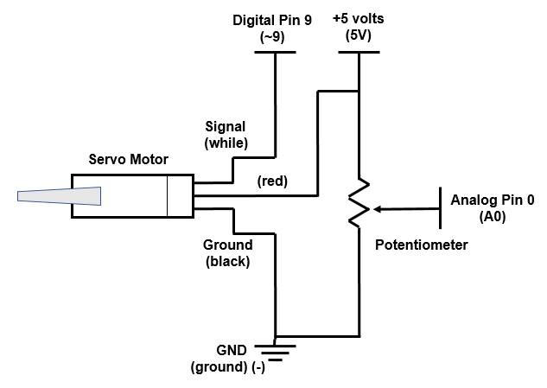

1. Required Resources

* SparkFun Inventors Kit (SIK) or equivalent components
* PC configured with Arduino drivers and Arduino software
* SparkFun SIK Guide Code example files
  1. Connect the circuits between the breadboard and RedBoard.

Refer to the Topology diagram for a visual reference of the following steps.

* + 1. Select 1 Servo, 1 Potentiometer, 3 black wires, 3 red wires, 1 blue wire and 1 white wire from the SIK.
    2. Insert the **Potentiometer** connecting leads to **b1**, **b2**, and **b3**.
    3. Connect the **Servo** using a black, a red, and a white jumper wire with their leads matching the colors coming out of the servo. The black lead connects to the **(-)** bar closest to row **j**, red to the **(+)** bar closest to row **j**, and white to **Digital Pin 9** **(~9**).
    4. Connect a black wire from **d3** to the **(-)** bar closest to row **j**.
    5. Connect a red wire from **d1** to the **(+)** bar closest to row **j**.
    6. Connect a blue wire from **d2** to the **Analog Pin 0** **(A0)**.
    7. Connect a black wire from the breadboard **(-)** bar to the **GND** on the RedBoard.
    8. Connect a red wire from the breadboard **(+)** bar to the **5V** pin on the RedBoard.
    9. **Note**: you may use some tape to hold the Servo motor on the table.
  1. Load and run the sketch in the Arduino IDE.
     1. Click the **up arrow** to display the examples folder. Select **SIK_Circuit_3A-Servo** from the **SIK-Guide-Code-V40** folder.

**Note**: The **SIK-Guide-Code-V40** folder will only exist if the code has been downloaded from <http://sparkfun.com/sikcode> and copied to the examples folder located under the Arduino program files, typically **C:\Program Files\Arduino\examples** or **C:\Program Files (x86)\Arduino\examples**.

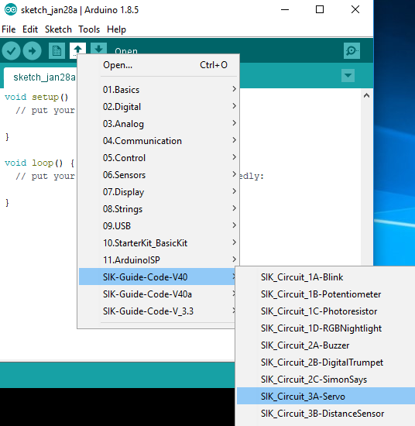

* + 1. Verify and compile the sketch to create an executable firmware that can be uploaded to the flash memory of the microcontroller.

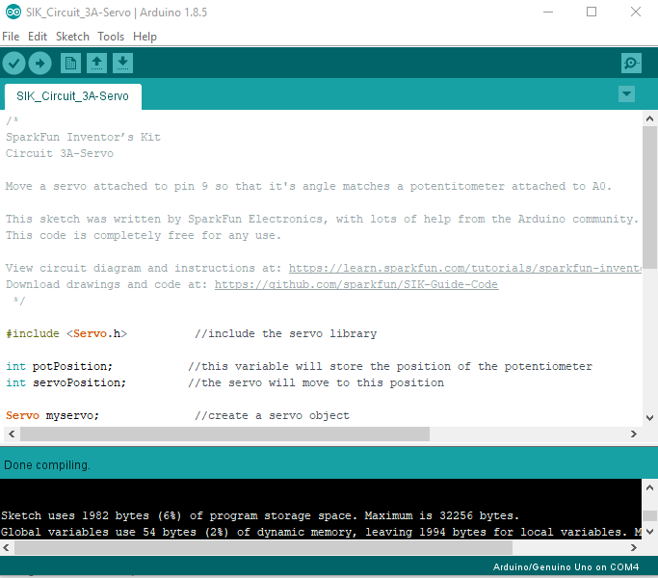

* + 1. Make sure the RedBoard is connected to the PC with the USB cable. Upload the firmware to the RedBoard.

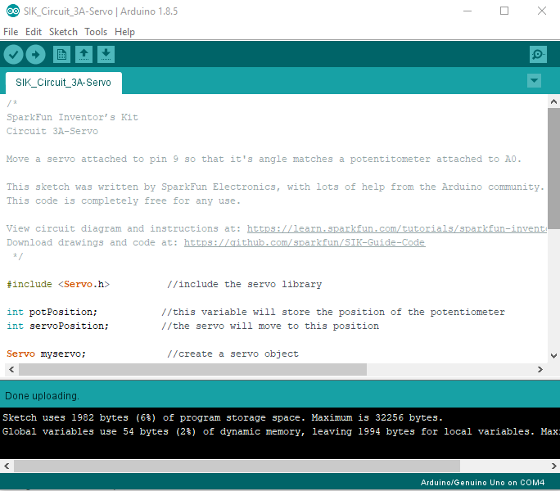

**Note**: If the firmware cannot be uploaded successfully, you may refer to Lab 2.2.2.5 for troubleshooting. Make sure that the correct COM port is used to connect the RedBoard.

* + 1. Rotate the knob on the Potentiometer clockwise. The Servo motor should turn clockwise depending on how much the knob is rotated. Rotate the knob on the Potentiometer counterclockwise. The Servo motor should also turn counterclockwise depending on how much the knob is rotated.

1. Reflection

Review the code. Which function and its parameter should be altered so that moving the potentiometer a lot only moves the servo a little?

In the map function, change the range values, the two last parameters of the function.